01/16/2025:

* Soldered header pins to PCB and connected PCB to rpi and bluepill - it fits!!

01/17/2025:

* Power levels seem to be correct throughout the PCB
  + Checked 3.3V and 5V spots with multimeter
* I need standoffs for rpi hat
* **ANOTHER GOAL:** make case for rpi with hat and bluepill??
* Expected output with original setup:
  + 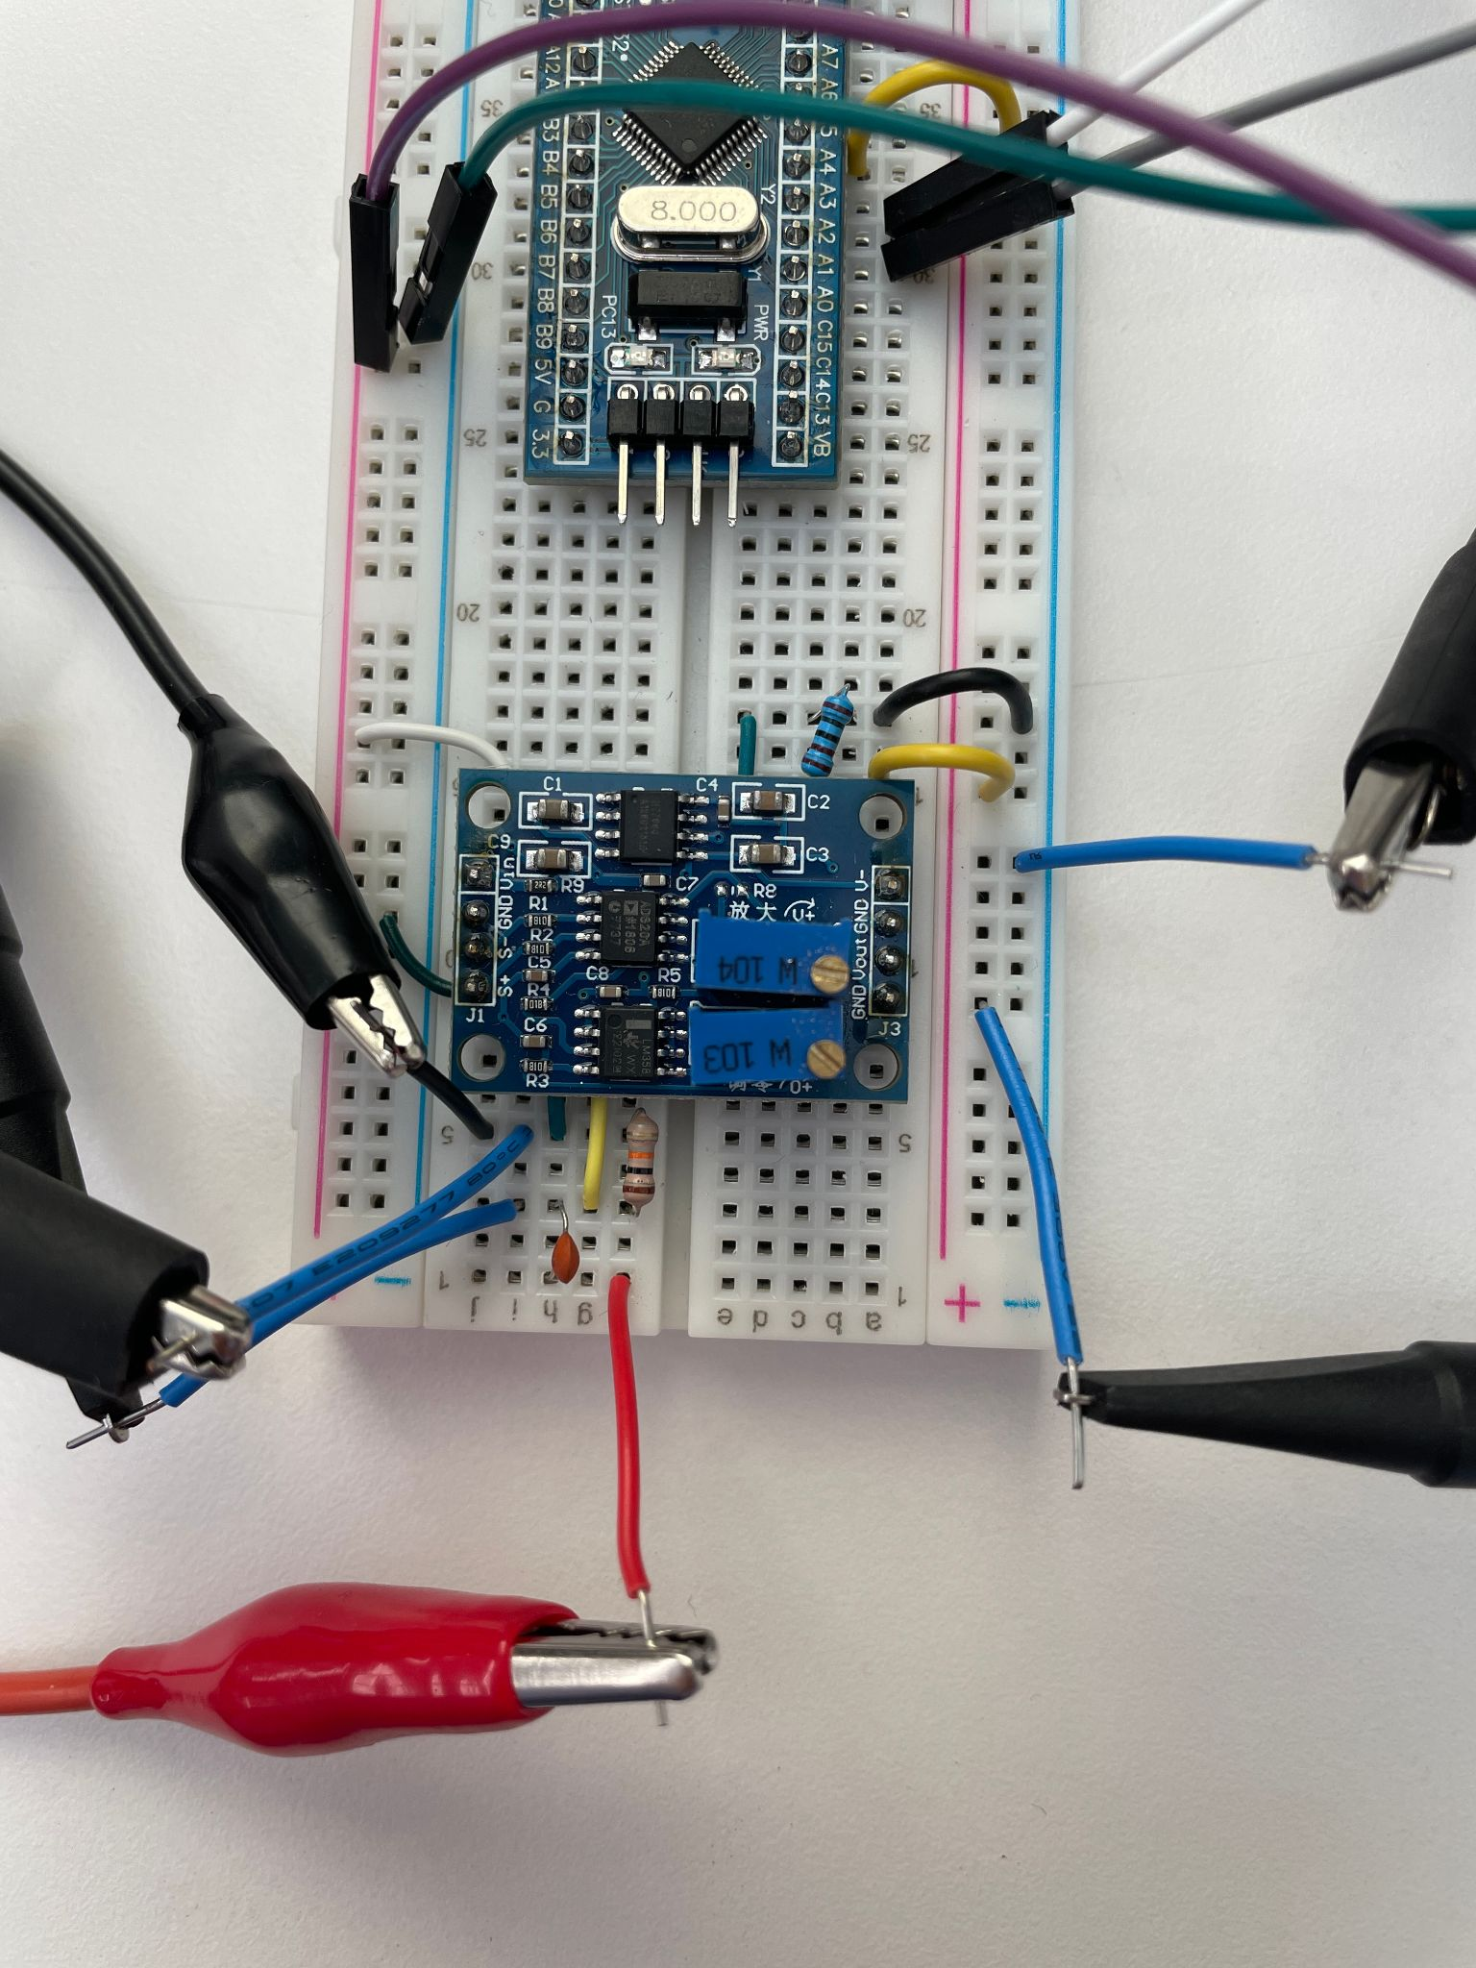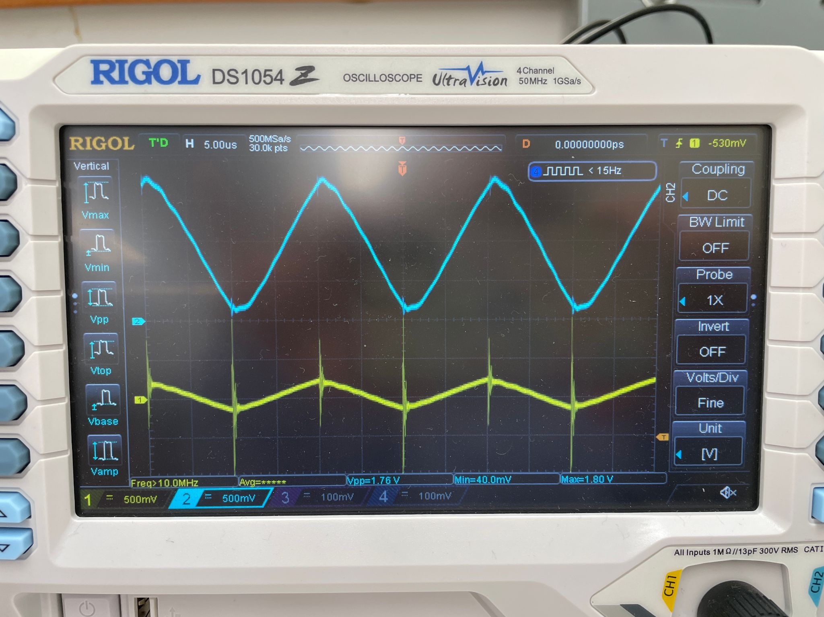
* New setup:
  + 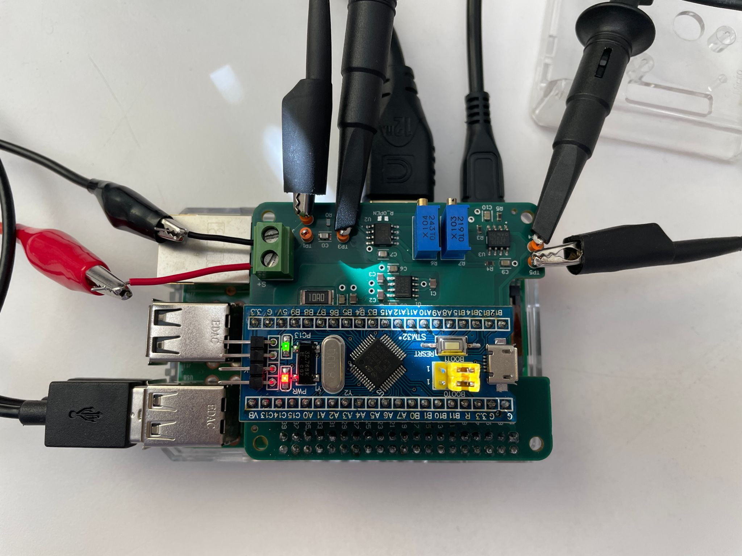
* **Something is wrong with R6**, it’s not adjusting gain of amplified signal
  + R7 works with adjusting DC offset though
  + **Teddy’s idea**: use multimeter to see if R6 is adjusting resistance
* Problem: Peaks and dips of amplified signal have weird fluctuations
  + 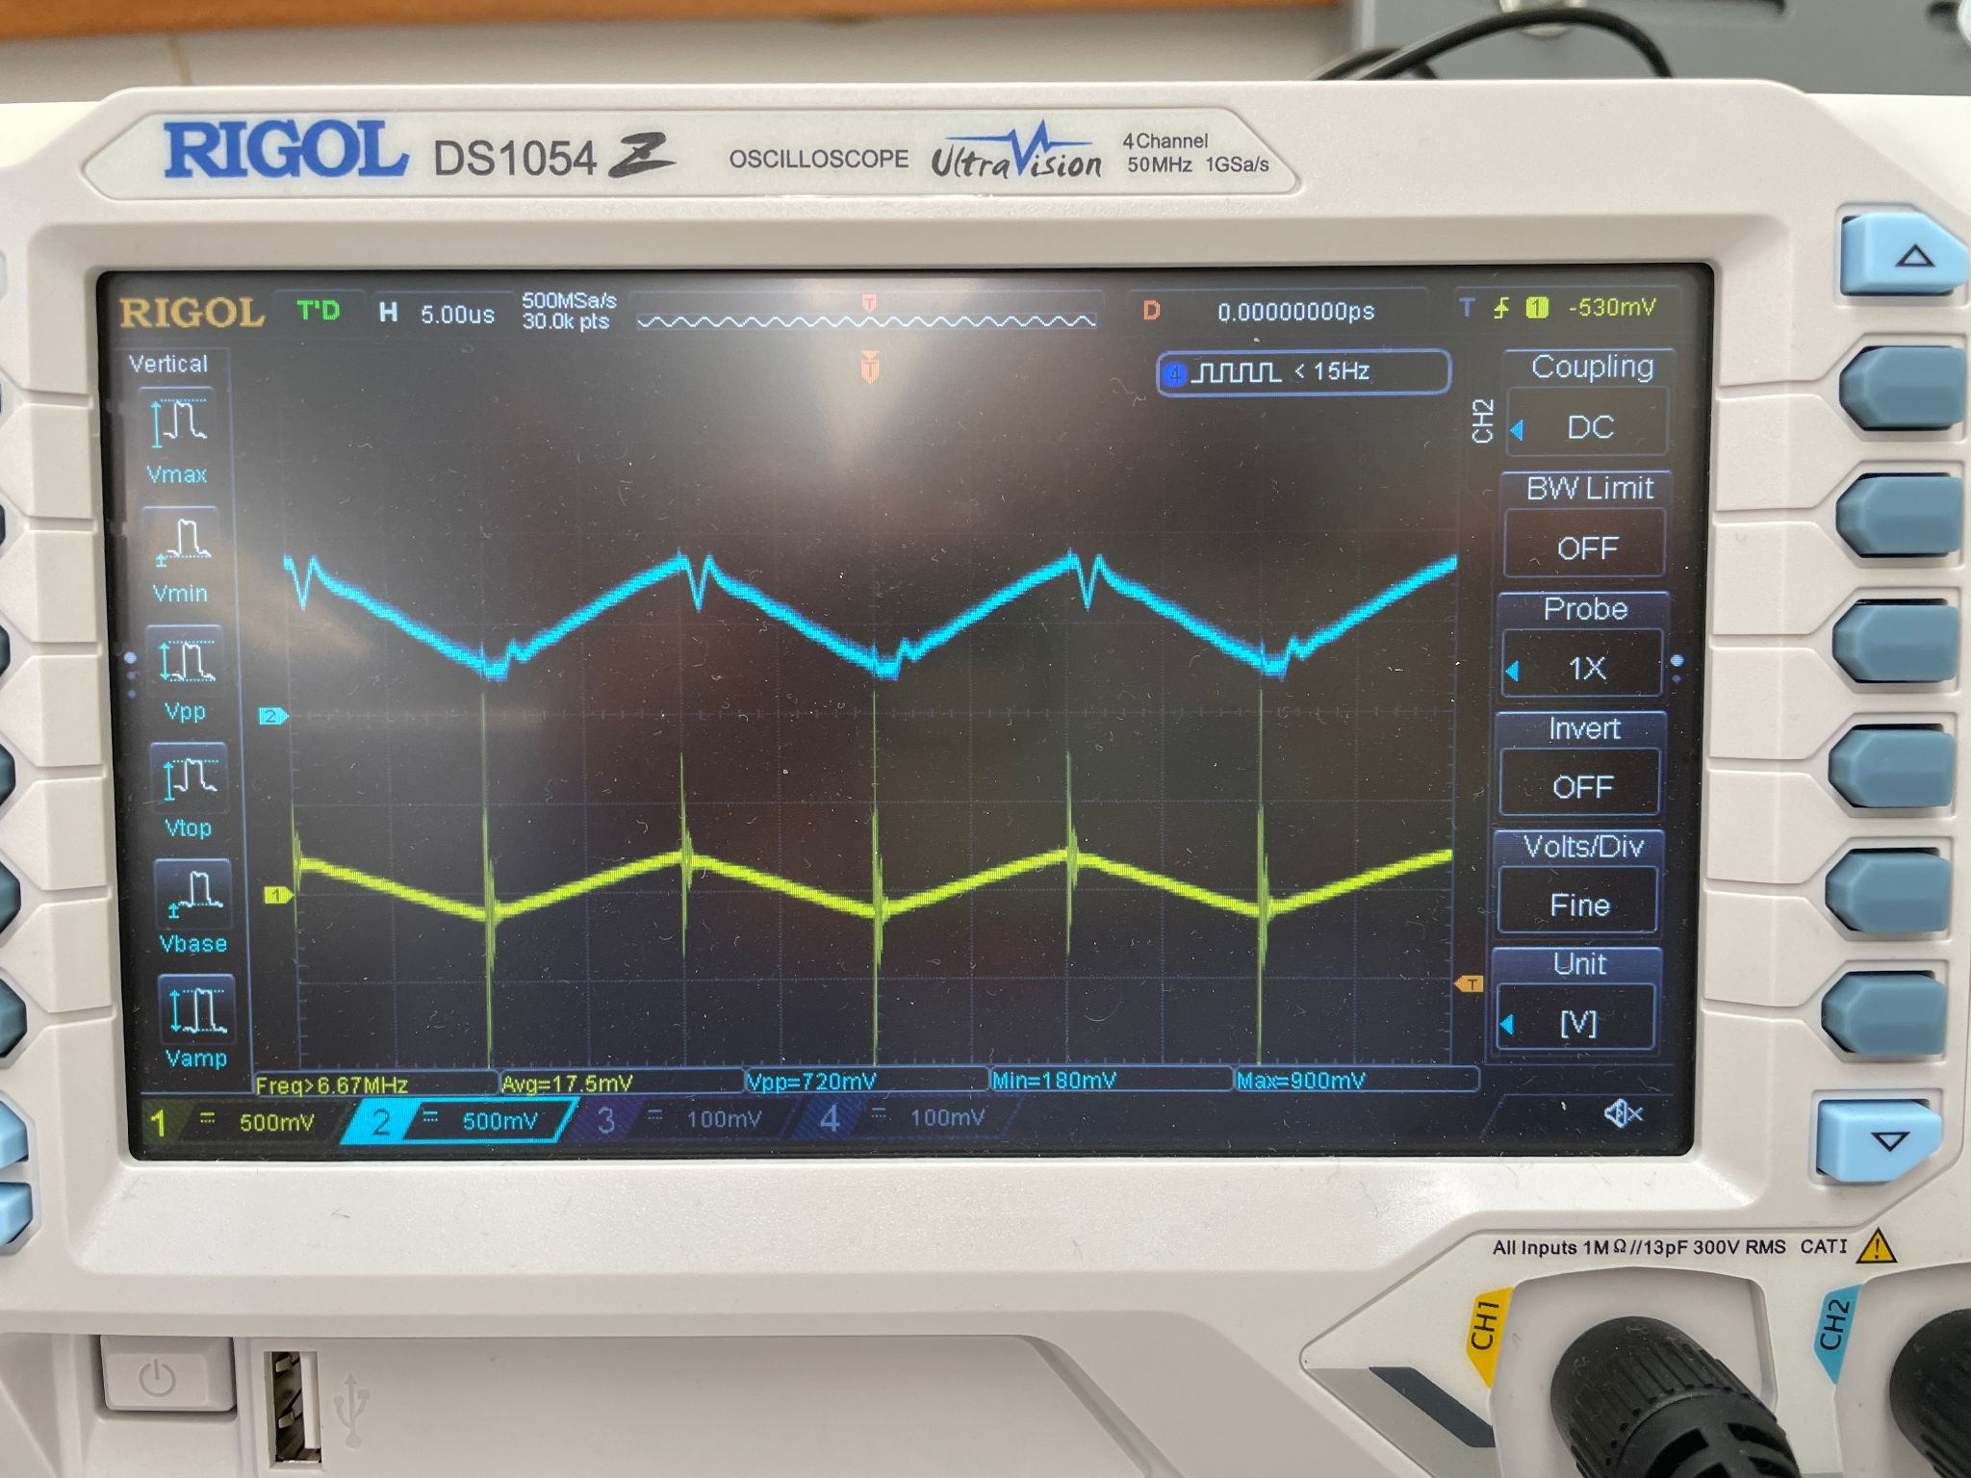
* Python script successfully ran!
  + 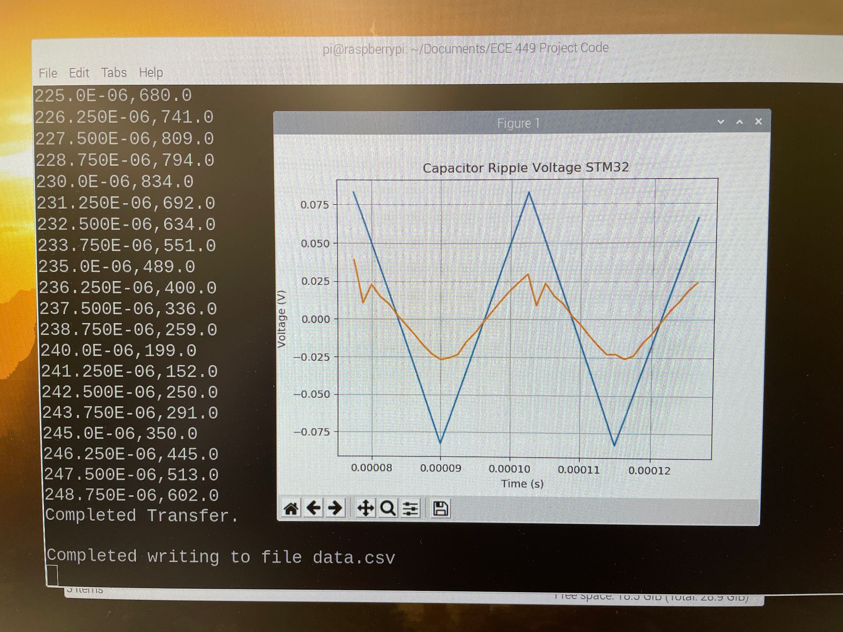
  + Problem listed before is very apparent in graph.
  + But I’m still happy about the success of everything interacting correctly!!
    - Ofc the issue is with the amplifier RIP
* Amplifier pots:
  + 104: 11.47k
  + 103: 10.42k
* PCB pots originally:
  + 104: 78.4k
  + 103: 9.78k
* PCB pots new:
  + 104: 13.25k
  + 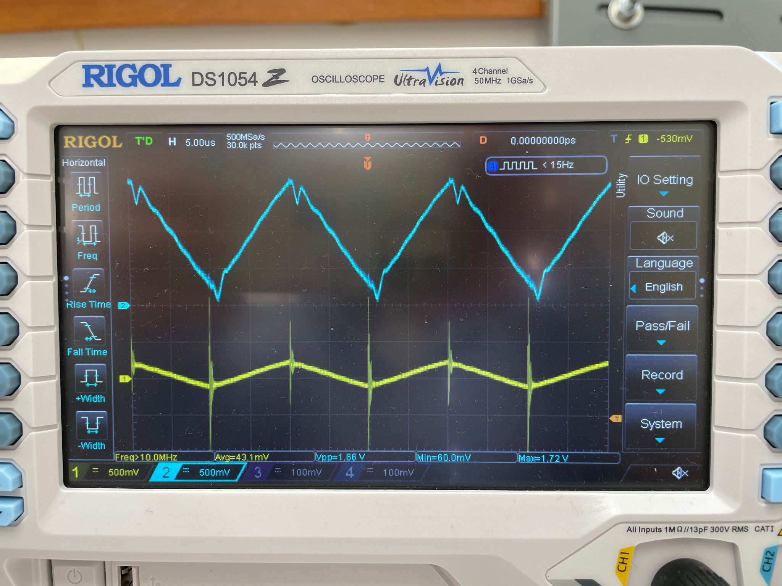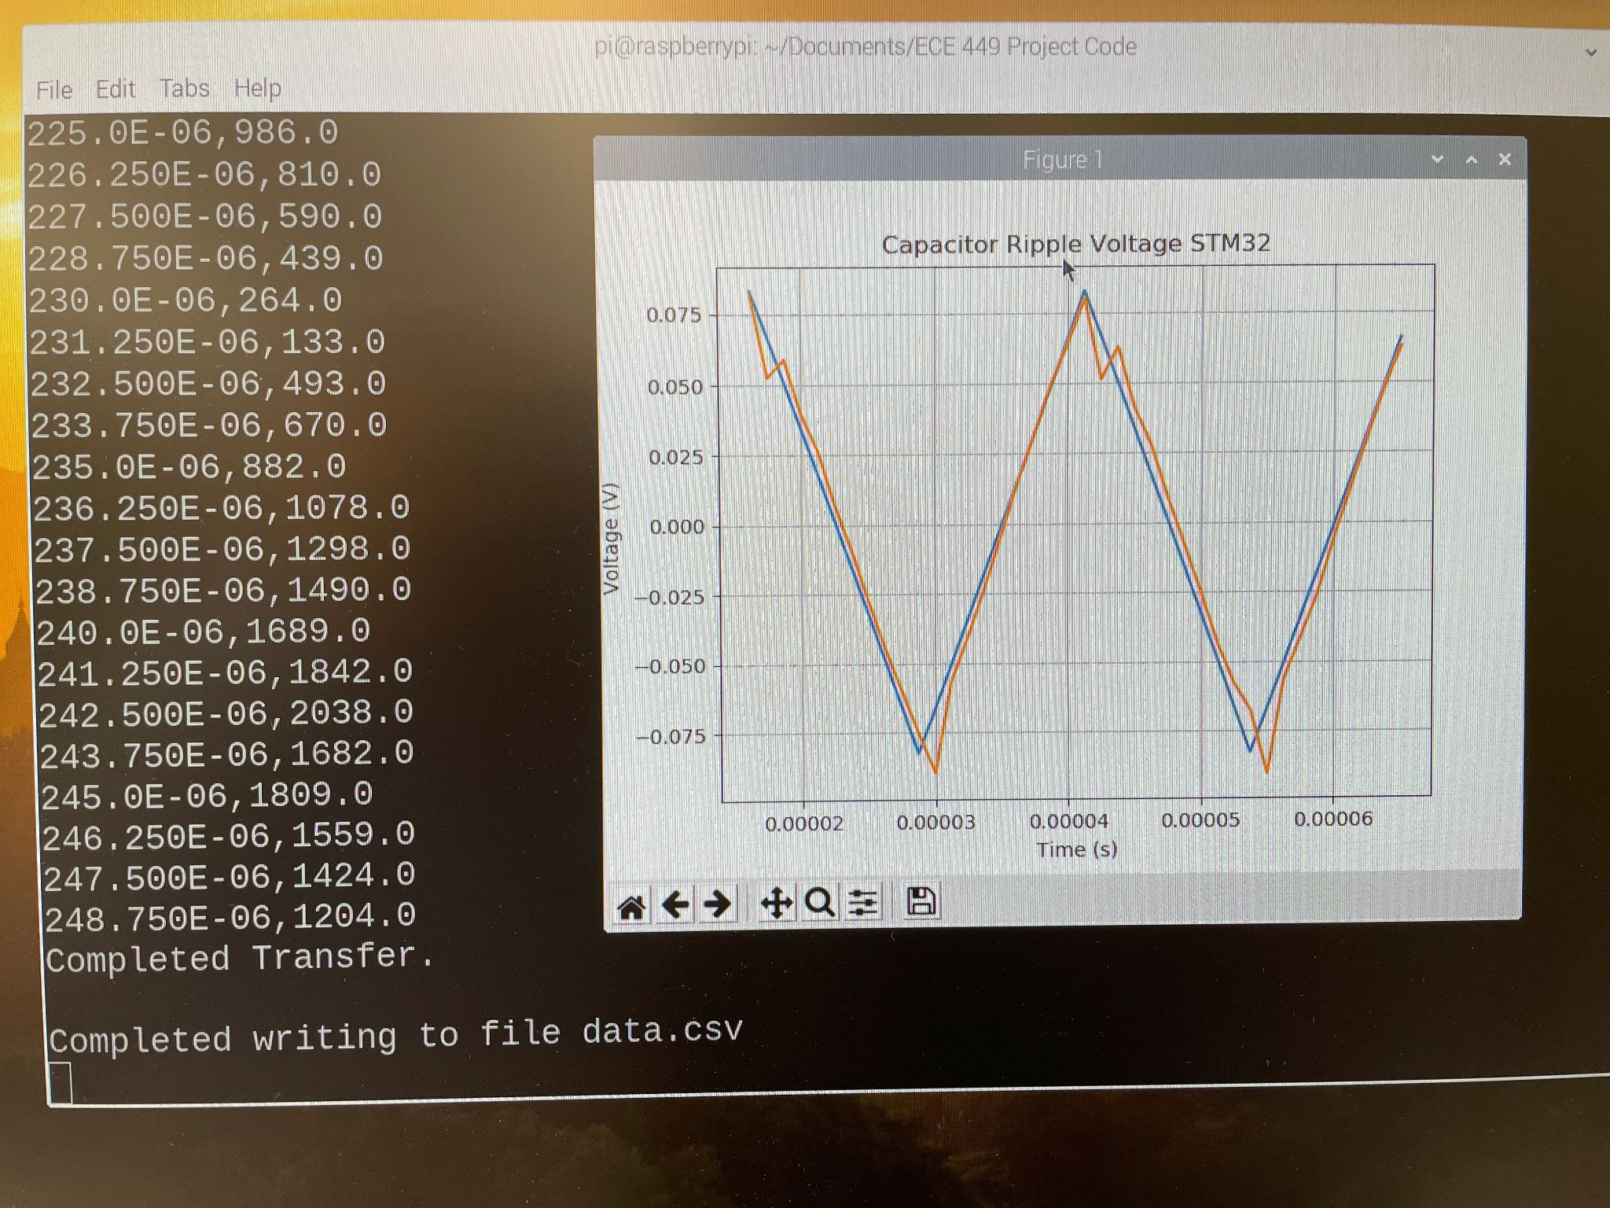
* **R6 Gain pot does work!!** It was just way too high before
* Dr. Scott said he doesn’t necessarily trust the previous group’s ripple voltage graph, so maybe mine could be correct

02/03/2025:

* Cant get the ST-link thing to work, whenever i try to run it, i keep getting this:
  + 
  + I remember i had this and fixed it at some point, but idk how. I’ll have to mess with it more later for the documentation
* After messing with the st link, the bluepill still works, i assume bc i never actually uploaded anything new to it
* I adjusted the ECE_449_RW_to_CSV.py script to add pseudo-live updates
  + Implemented for loop to repeat sampling and plot creating a finite, defined number of times
  + **GOAL:** i’d like to make this better/more visually appealing, so look into it further perhaps
* I really don’t have much to do this semester besides documentation/report writing and this pseudo-live updates which i did today, so maybe i should revisit doubling the Bluepill samplerate

02/06/2025:

* **Met with dr scott, review meeting notes and prepare for meeting on tuesday**

02/10/2025:

* Prep for dr scott meeting:
  + Previous capstone [wiki](https://github.com/Epsilon391/High-Frequency-Sampling-for-Circuit-Analysis/wiki) contains info on Blue Pill ADC calculations and what the numbers mean

02/11/2025:

* More prep for dr scott meeting:
  + Adc.c:
    - Sample rate is set to 50 kHz with math
      * Buck converter has 50 kHz frequency
    - setTimerFreq: arr = 1439 ??
  + DMA : direct memory access - used for ADC and UART
* Investigate if double sample rate with blue pill is possible:
  + “Interleaved sample and hold” [Blue Pill documentation](https://drive.google.com/drive/folders/12kG1ENfDFfBQalTvLypfInGZUYFLtnHz) ADC pg 20
  + <https://community.st.com/t5/stm32-mcus-products/stm32f103c8t6-fast-interleaved-adc-gives-samples-in-wrong-order/td-p/339103>
    - STM32F108C6
  + <https://stackoverflow.com/questions/54024674/stm32f3-dual-adc-with-interleaved-mode>
    - Uses different board
  + <https://www.youtube.com/watch?v=AloHXBk6Bfk>
    - Uses different board
  + <https://community.st.com/t5/stm32-mcus/adc-interleaved-mode-1-2-nbsp-how-to-improve-adc-sampling-rate/ta-p/49295>
    - <https://community.st.com/t5/stm32-mcus/adc-interleaved-mode-2-2-nbsp-hands-on-stm32cubeide-project/ta-p/49715>
    - Uses different board
  + <https://www.youtube.com/watch?v=nUejeLYKmfw>
    - Uses different board

02/12/2025:

* Most links from yesterday use different boards so different settings are available
* <https://github.com/codenuke/STM32-Library-V3.5/blob/master/Project/STM32F10x_StdPeriph_Examples/ADC/RegSimul_DualMode/main.c>
  + STM32F10x ✅
  + Possible starting point for code
* STM32F103C8T6:
  + <https://community.st.com/t5/stm32-mcus-products/stm32f103c8t6-fast-interleaved-adc-gives-samples-in-wrong-order/td-p/339103>
* STM32F10 interleaved ADC, stm32 forum pages:
  + <https://community.st.com/t5/stm32-mcus-products/problem-in-using-dma-for-adc-fast-interleaved-mode-in/td-p/534488>
  + <https://community.st.com/t5/stm32-mcus-products/adc-stm32f1-interleaved/td-p/409387>
* Ever since Dr. Scott came in and looked at/messed with my setup, the amplification of the signal has been too low. I’m going to try to adjust the pot again, but what the heck
  + I adjusted the pots and got it to about the size of the ideal path

02/18/2025:

* Think about future work for Dr. Scott potential research student continuing this project

02/26/2025:

* I think i’m missing a resistor at the output of the amplifier omg
  + Seen in the schematic [here](https://github.com/clairehopfensperger/OSGC_Research_Virtual_Twinning/wiki/Z.-Original-System-Setup) on the output of the amp
  + But not in my design [here](https://github.com/clairehopfensperger/OSGC_Research_Virtual_Twinning/wiki/D.-OSGC-PCB-Design-Process)
* Try adding the resistor to the output tomorrow? I got a 1k ohm resistor and put in near my PCB on rPi

02/27/2025:

* Before adding 1 kOhm resistor to amp output:
  + 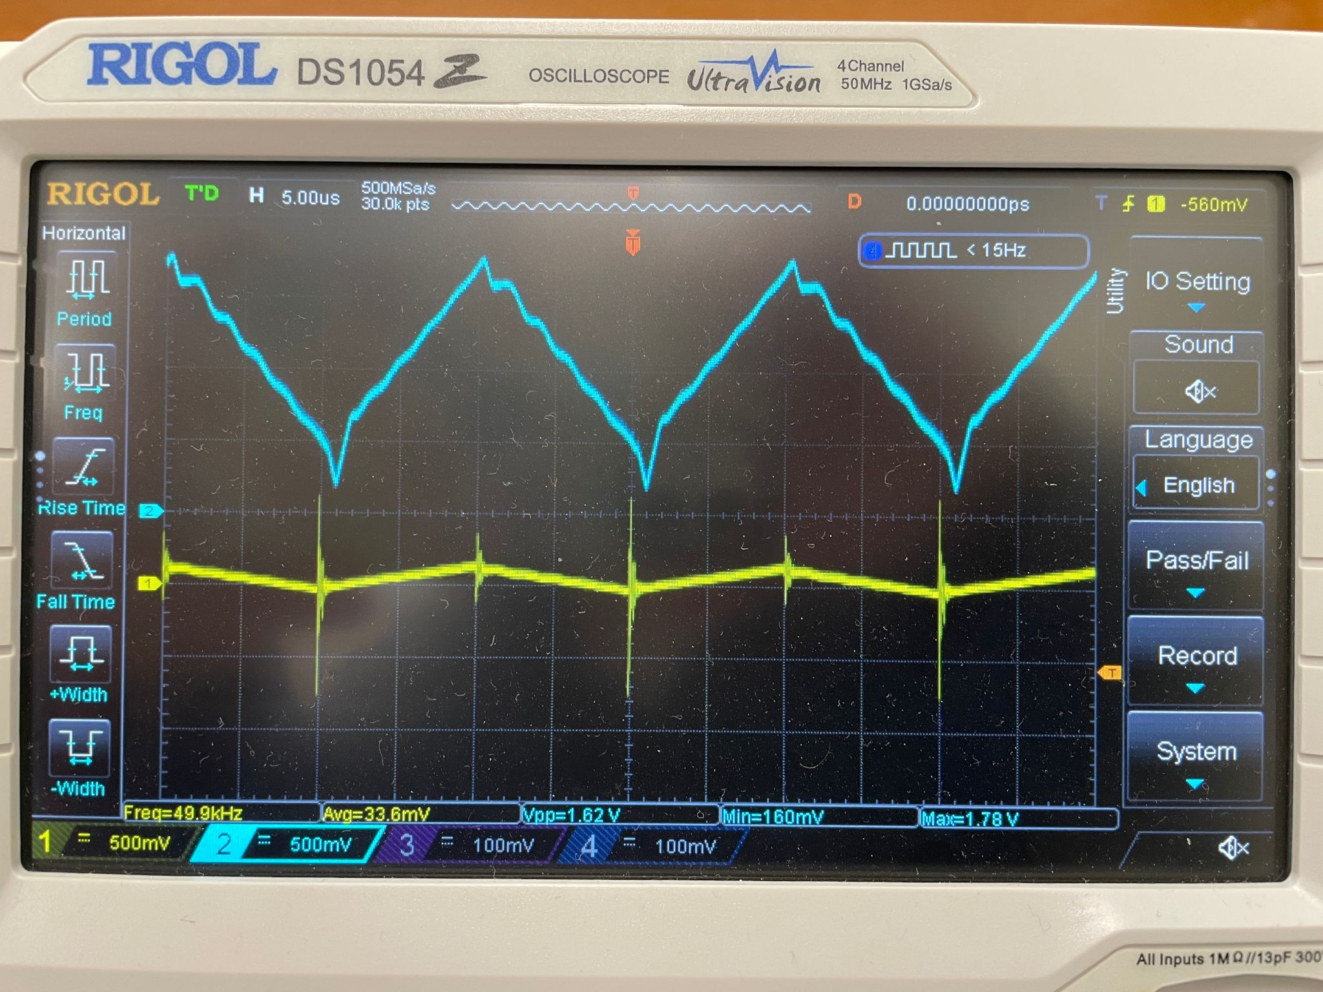
* After adding the 1 kOhm resistor:
  + 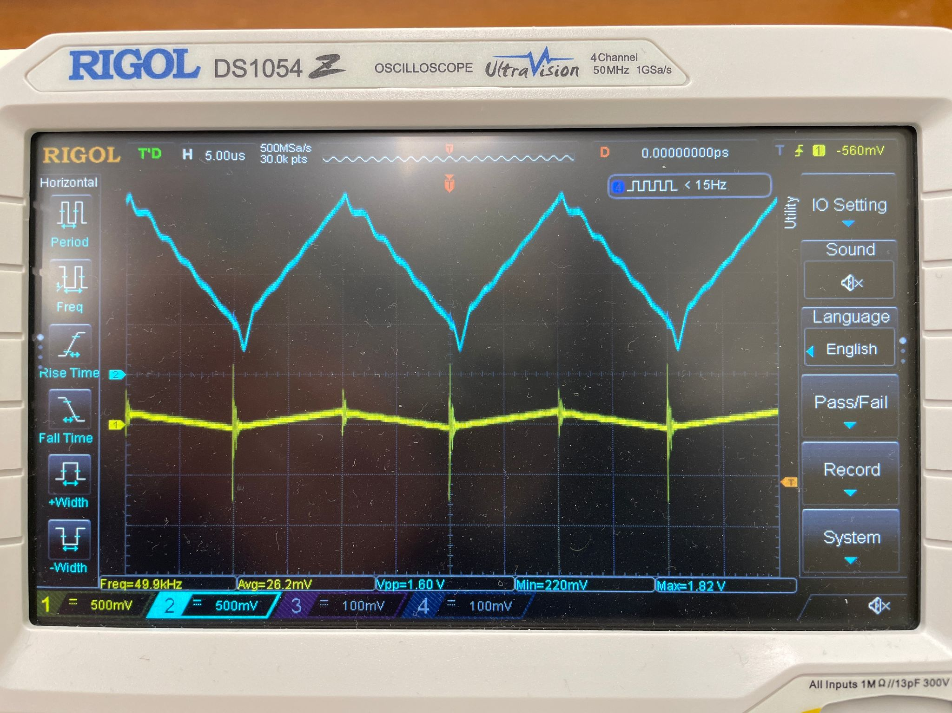
* I don’t observe a significant enough effect from the 1 kOhm resistor

03/06/2025:

* To do:
  + Verify length of OSGC presentation
  + Add resistor at end of amp?
  + Start writing OSGC paper
  + Start OSGC presentation